2024年中考考前最后一卷（广西卷）



地理·答题卡

姓 名：__________________________

准考证号：

贴条形码区

考生禁填： 缺考标记



违纪标记



以上标记由监考人员用**2B铅笔**填涂

选择题填涂样例：

正确填涂



错误填涂 **[×] [√] [／]**



1．答题前，考生先将自己的姓名，准考证号填写清楚，并认真核准条形码上的姓名、准考证号，在规定位置贴好条形码。

2．选择题必须用2B铅笔填涂；填空题和解答题必须用0.5 mm黑色签字笔答题，不得用铅笔或圆珠笔答题；字体工整、笔迹清晰。

3．请按题号顺序在各题目的答题区域内作答，超出区域书写的答案无效；在草稿纸、试题卷上答题无效。

4．保持卡面清洁，不要折叠、不要弄破。

注意事项

**第Ⅰ卷（请用2B铅笔填涂）**

|  |  |  |  |
| --- | --- | --- | --- |
| 1 [A] [B] [C] [D]  2 [A] [B] [C] [D]  3 [A] [B] [C] [D]  4 [A] [B] [C] [D]  5 [A] [B] [C] [D] | 6 [A] [B] [C] [D]  7 [A] [B] [C] [D]  8 [A] [B] [C] [D]  9 [A] [B] [C] [D]  10 [A] [B] [C] [D] | | 11 [A] [B] [C] [D]  12 [A] [B] [C] [D]  13 [A] [B] [C] [D]  14 [A] [B] [C] [D]  15 [A] [B] [C] [D] |
|  | |
|  |  | |  |
|  |  | |  |

**第Ⅱ卷（请在各试题的答题区内作答）**

16.（6分）

（1）（2分）__________________________ __________________________

（2）（1分）__________________________

（3）（2分）__________________________ __________________________

（4）（1分）_____________________________________________________________

17.（6分）

（1）（2分）__________________________ __________________________

（2）（2分）__________________________ __________________________

（3）（2分）__________________________

请在各题目的答题区域内作答，超出黑色矩形边框限定区域的答案无效！

_______________________________________________________

18.（6分）

（1）（1分）__________________________

（2）（2分）__________________________ __________________________

（3）（1分）__________________________

（4）（2分）__________________________

________________________________________________________________________

19．（6分）

（1）（2分）__________________________ __________________________

（2）（1分）__________________________

（3）（1分）__________________________

（4）（1分）_____________________________________________________________

（5）（1分）_____________________________________________________________

20．（6分）

（1）（2分）__________________________ __________________________

（2）（2分）

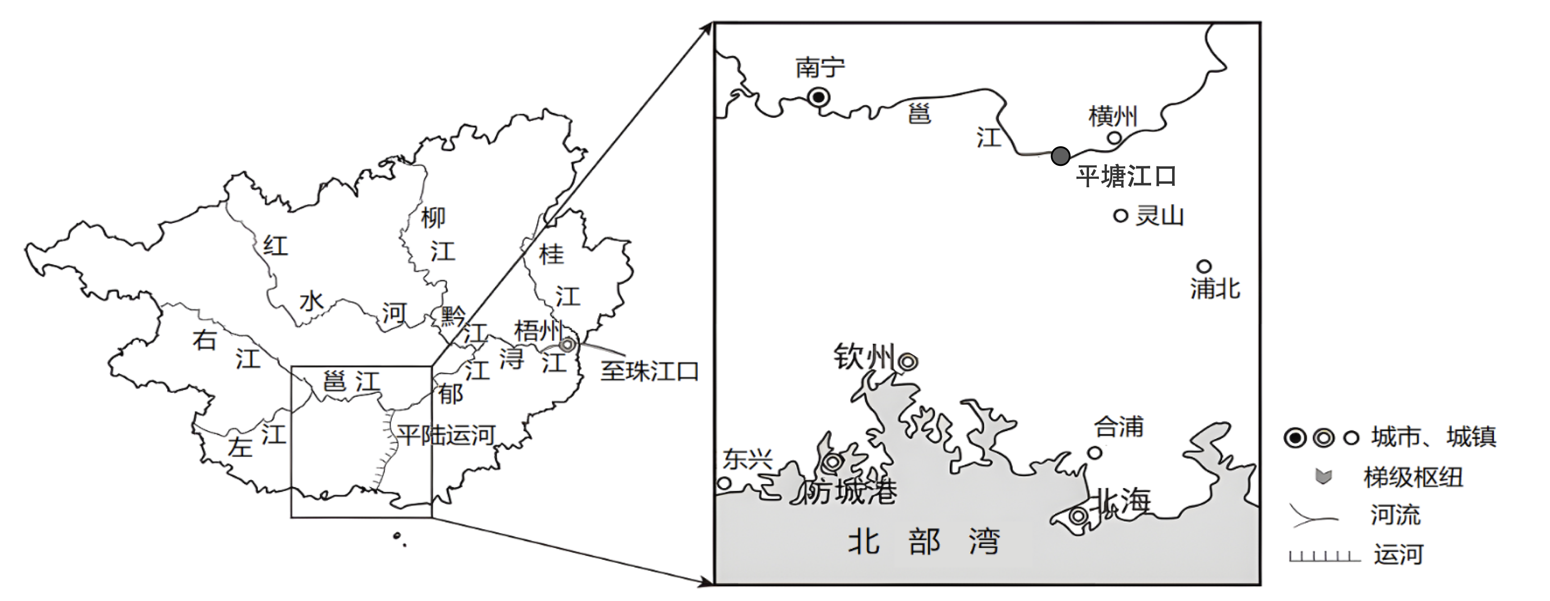

（3）（2分）________________________________________________________

_____________________________________________________________________

请在各题目的答题区域内作答，超出黑色矩形边框限定区域的答案无效！

请在各题目的答题区域内作答，超出黑色矩形边框限定区域的答案无效！

非

答

题

区

域

请在各题目的答题区域内作答，超出黑色矩形边框限定区域的答案无效！

请在各题目的答题区域内作答，超出黑色矩形边框限定区域的答案无效！

请在各题目的答题区域内作答，超出黑色矩形边框限定区域的答案无效！